**Test Case 1 No change:**

**Given:**

Price: $50

Amount Given: $50

**When:**

Running the code

**Then the output should be:**

No change

**Results:**

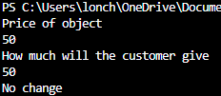

**Test Case 2 Can't afford:**

**Given:**

Price: $500

Amount Given: $50

**When:**

Running the code

**Then the output should be:**

Can’t afford

**Results:**

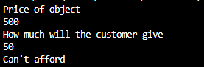

**Test Case 3 One of each bill:**

**Given:**

Price: $0

Amount Given: $888

**When:**

Running the code

**Then the output should be:**

1: 1

2: 1

5: 1

10: 1

20: 1

50: 1

100: 1

200: 1

500: 1

**Results:**

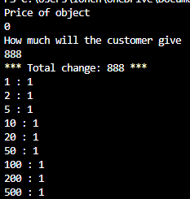

**Test Case 4 One of each coin:**

**Given:**

Price: $0

Amount Given: $0.80

**When:**

Running the code

**Then the output should be:**

0.10: 1

0.20: 1

0.50: 1

**Results:**

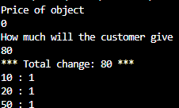

**Test Case 5 One of each coin and bill:**

**Given:**

Price: $1000

Amount Given: $1888.88

**When:**

Running the code

**Then the output should be:**

0.10: 1

0.20: 1

0.50: 1

1: 1

2: 1

5: 1

10: 1

20: 1

50: 1

100: 1

200: 1

500: 1

**Results:**

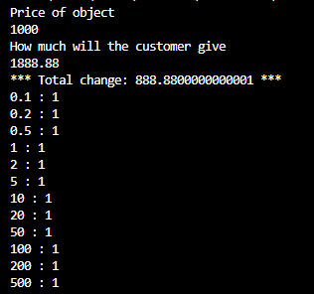

**Test Case 6 Some bills:**

**Given:**

Price: $420

Amount Given: $890

**When:**

Running the code

**Then the output should be:**

20: 1

50: 1

200: 1

**Results:**

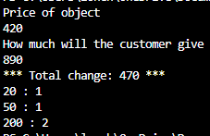

**Test Case 7 Some coins:**

**Given:**

Price: $0.30

Amount Given: $0.99

**When:**

Running the code

**Then the output should be:**

0.1: 1

0.5: 1

**Results:**

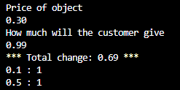

**Test Case 8 Some coins and some bills:**

**Given:**

Price: $420.30

Amount Given: $890.90

**When:**

Running the code

**Then the output should be:**

0.1: 1

0.5: 1

20: 1

50: 1

200: 1

**Results:**

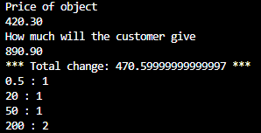

**Test Case 9 Only one bill:**

**Given:**

Price: $400

Amount Given: $500

**When:**

Running the code

**Then the output should be:**

100: 1

**Results:**

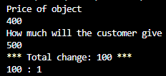

**Test Case 10 Only one coin:**

**Given:**

Price: $0.50

Amount Given: $0.75

**When:**

Running the code

**Then the output should be:**

0.20: 1

**Results:**

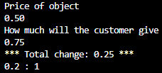

**Test Case 11 Only one coin and bill:**

**Given:**

Price: $500.50

Amount Given: $600.60

**When:**

Running the code

**Then the output should be:**

100: 1

0.10: 1

**Results:**

